## Batch uploading direct from SDE to SLIP self Service

## Installing PIP

Download [get-pip.py](https://bootstrap.pypa.io/get-pip.py) to c:\python27\arcgis10.2

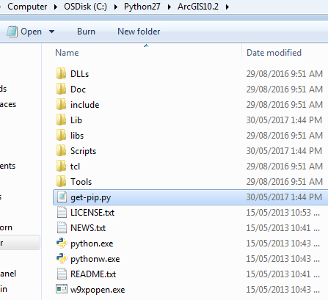

Open a command prompt window and navigate to the folder containing get-pip.py file. Then run

>python get-pip.py

This will install PIP

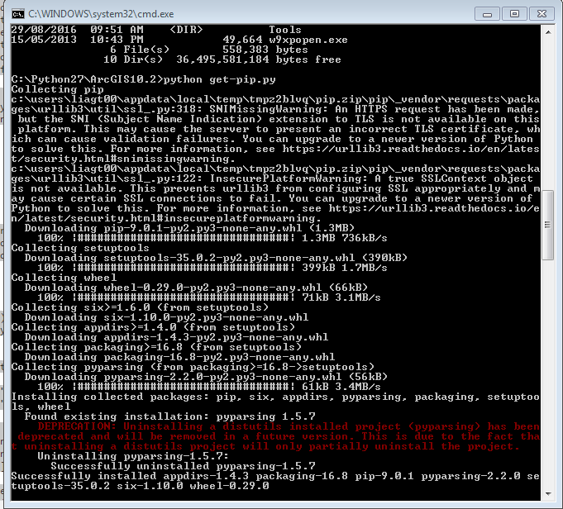

>c:\python27\ArcGIS10.2\python c:\temp\get-pip.py

This will install pip.

You can now use pip to install the boto3 python modules by navigating into the pythons scripts folder and executing

c:\Python27\ArcGIS10.2\Scripts\pip.exe install pip

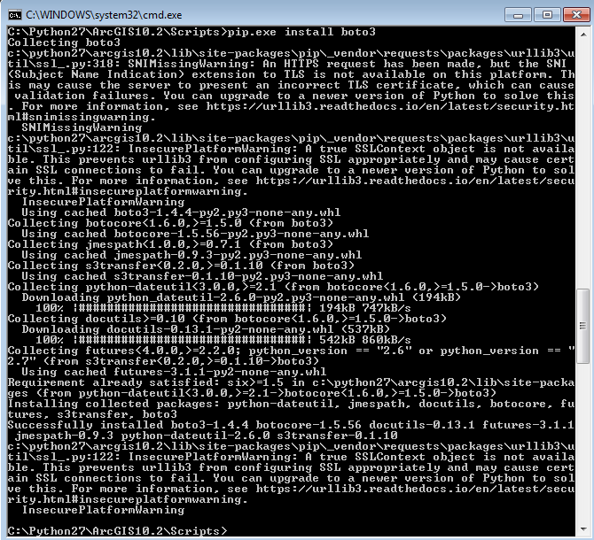

Download the scripts from <https://github.com/datawagovau/SLIP-Self-Service-Toolkit> to a folder on your computer ie (c:\selfservice_uploads)

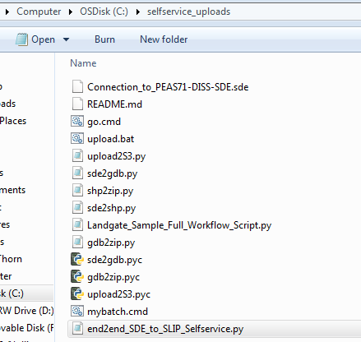

Install AWS CLI <https://s3.amazonaws.com/aws-cli/AWSCLI64.msi>

Open a command prompt and set up your credentials according to your agency. You can find the credential from the Upload tab of self-service.

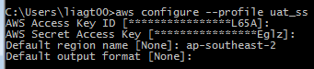

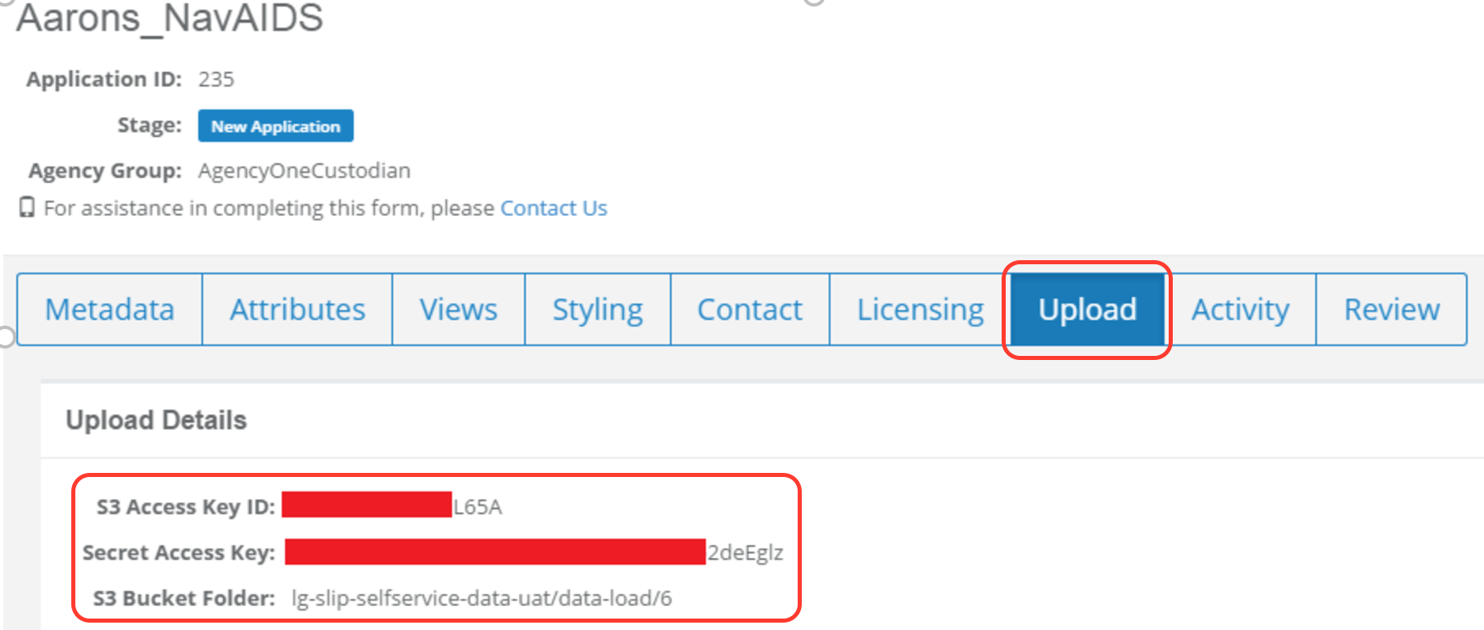

Edit SDEtoSelfservice_batch.bat and configure the variables to your own environment/dataset.

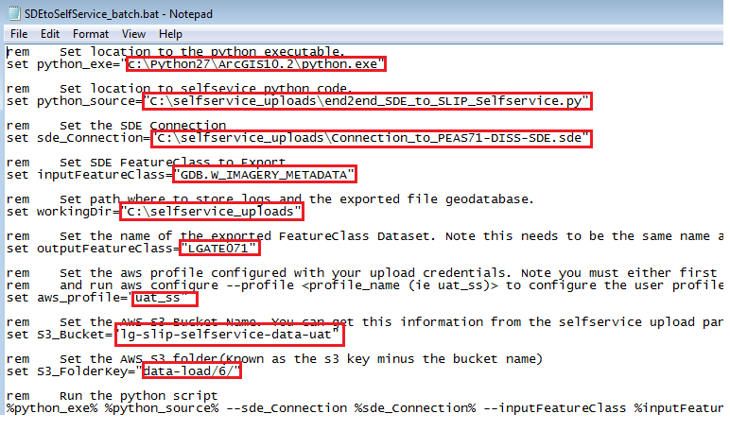

You can now test the batch by executing SDEtoSelfservice_batch.bat

Executing this batch will create a log file and zip file containing your data, along with date stamp.



It should also upload your data to selfservice.

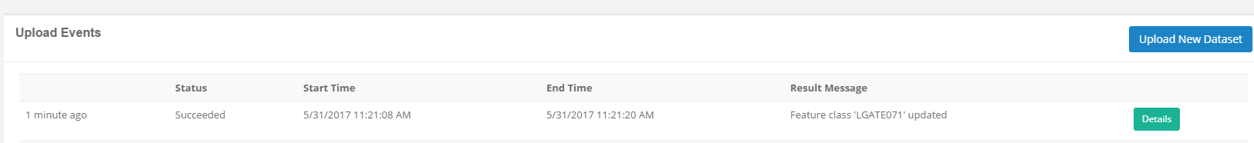

Any errors will be logged inthe log file.

To schedule this job to run at regular intervals open window task scheduler and select create basic task...

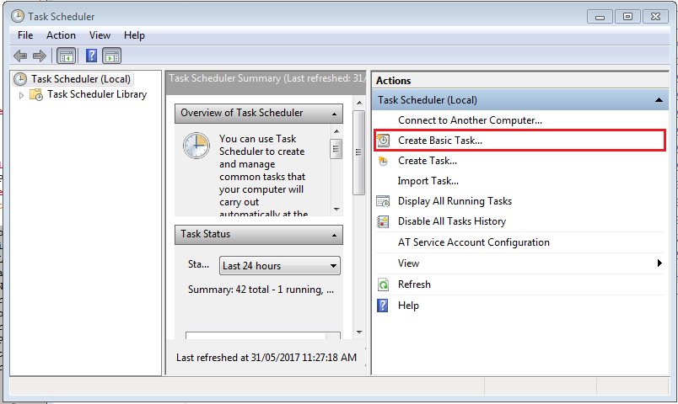

Type in a meaningful task name and description.

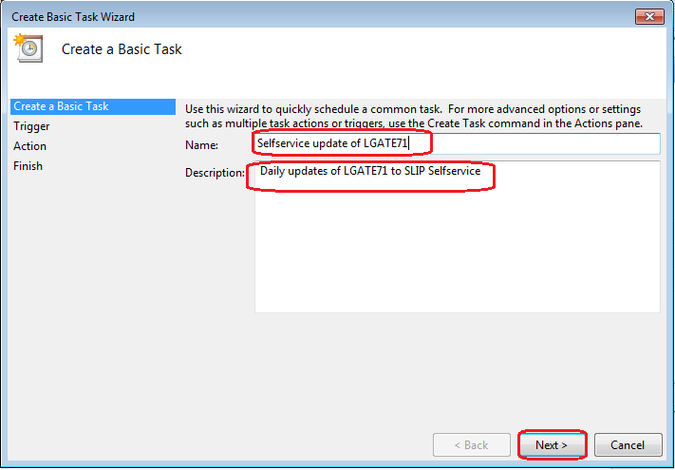

Select how often you want the task to run

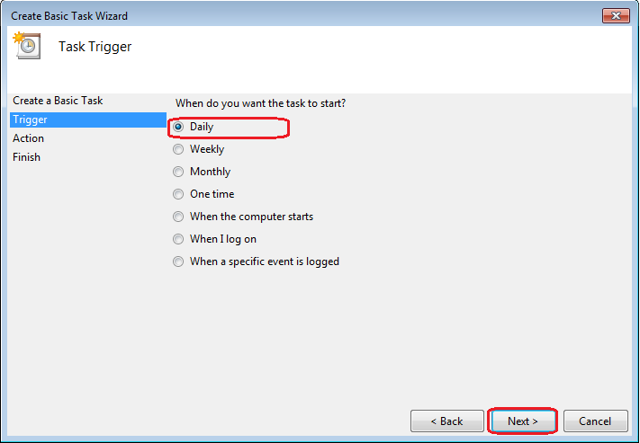

Enter what time you want to execute the task

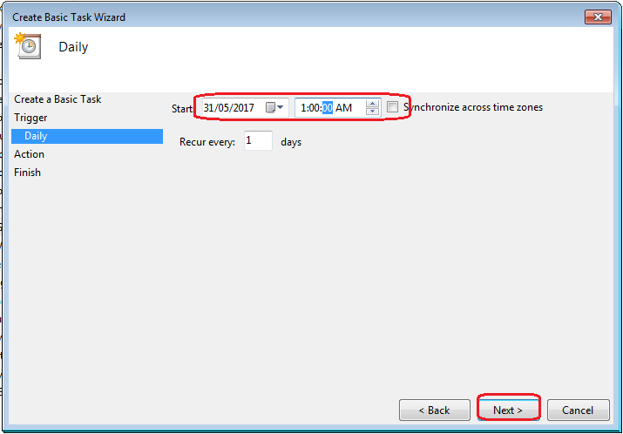

Select Start a Program

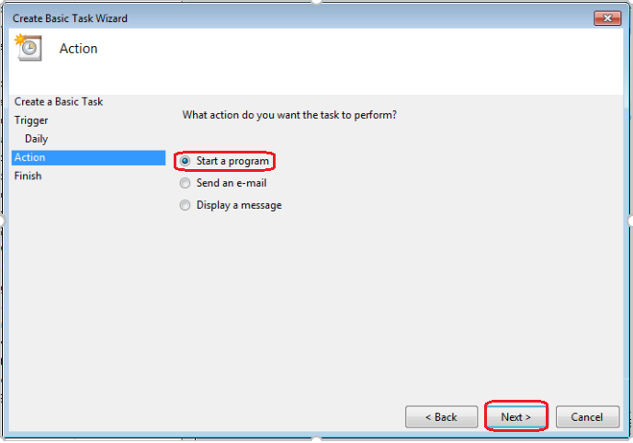

Navigate to your batch file

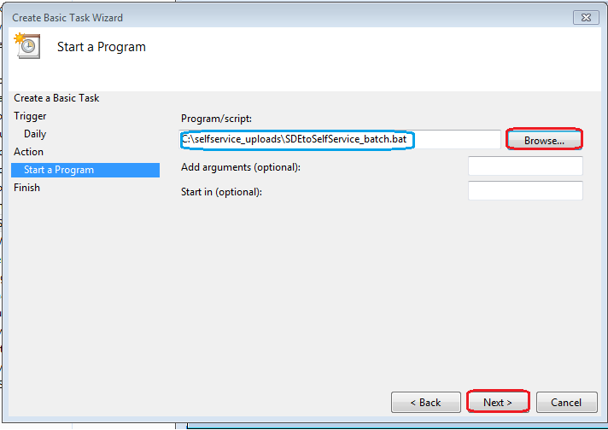

Your newly created task will now be shown in the task scheduler Library

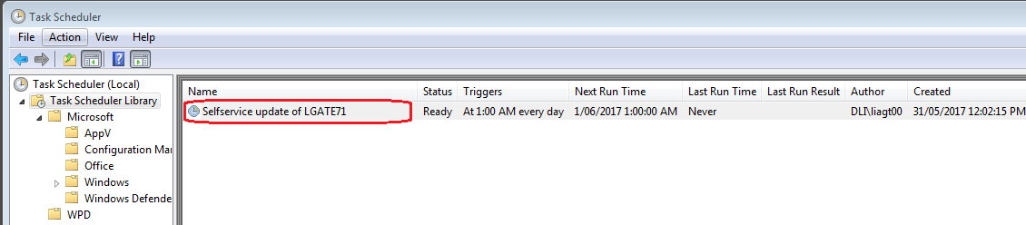

Right click on your task and select properties

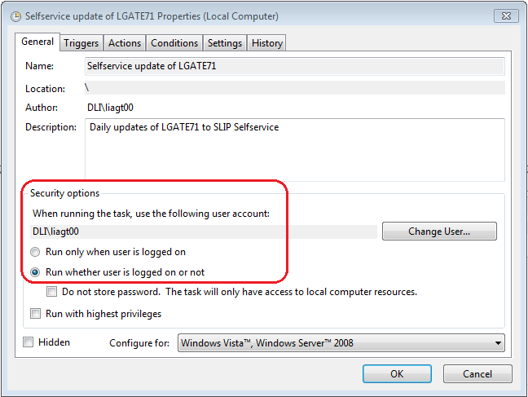

Configure the security options. Note if your account password expires the task will not execute. It is recommended to use a service account that’s password never expires.